Phase 2: Elaboration 1

Update

Initially, we had designed a project with a large scope with ambitious deliverables that would be like the City of Toronto’s Open Data. Upon further review and additional input from the course instructor, we reduced the scope of the project so that the goals would align themselves with the capabilities of the team. This included reducing the scope to a more manageable goal, while using an object-oriented language such as Java. Consequently, this enabled us to focus on a narrower aspect of the project, which is to create a Java based data interpreter that would pull data from the City of Windsor Data Portal’s data repository.

The Phase Plan

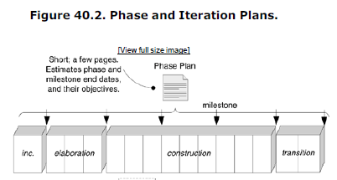According the textbook’s definition, the phase plan’s purpose is to outline the milestones that would be taking place during the software development process while outlining the dates and objectives certain milestones would take place.

Iteration plan lays out the macro-level milestone dates and objectives, such as the end of phases and mid-phase pilot test milestones. The Iteration Plan defines the work for the current and next iteration not all iterations

Our implementation will be based on the low coupling GRASP design patterns and high cohesion that would facilitate the production of quality code that would enable maintenance, reusability and legibility of the code.

The following outlines the schedule and events that would be happening including the collaboration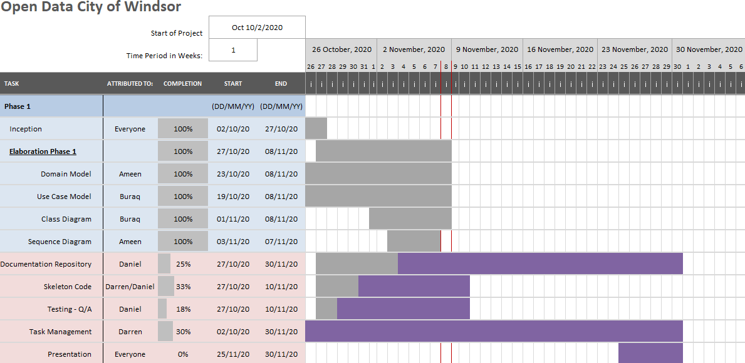 tools used to achieve them:

For detailed schedule, please click on following link (!!!THIS CAN BE EDITED OR REMOVED and placed in a separate page):

<https://teams.microsoft.com/l/file/17bd2c2e-84bc-48e3-b29f-8b9ea6850ebf?tenantId=12f933b3-3d61-4b19-9a4d-689021de8cc9&fileType=pdf&objectUrl=https%3A%2F%2Fuwin365-my.sharepoint.com%2Fpersonal%2Fxued_uwindsor_ca%2FDocuments%2FMicrosoft%20Teams%20Chat%20Files%2FphasePlan.pdf&baseUrl=https%3A%2F%2Fuwin365-my.sharepoint.com%2Fpersonal%2Fxued_uwindsor_ca&serviceName=p2p&threadId=19:c457712459684820a533a4e0bdd3b829@thread.v2>

On October 27th, 2020 project documention is held inside our Github repository in a README file. There we describe the purpose and way to utilize the program to obtain the data from the City of Windsor.

Because of the numerous ways to use Github, it’s responsible for maintaining version control, bug reporting and code repository.

Project Management tasks are maintained continuously throughout the lifetime of the project in Microsoft teams, Github and a shared Microsoft Excel document for visibility.

The main tasks for this iteration, is to implement the skeleton code and conduct some basic testing. Both tasks were started on October 27, 2020 and are currently 33% and 18% completed respectively.

Testing Stratergies:

Since the project will be approached with an agile based approach testing of different release will ensure we have a working and accurate product at the end of each new update that is introduced.

We will start by first testing the code’s ability to read and store the data it will work on in the course of the project and ensure that the data is stored correctly and is easily accessible when needed. Phase II of the testing will include working with the data stored in phase I and filtering the data. Phase III of the testing strategy will have the complete product ready for testing ensuring all the errors were corrected and have a full functional code.

The phases will start with focus firstly being on the readily available data and its interpretation and the phases will move onto testing the data for the teams requirements and finally end with testing the data for the requirements of the client.

Automated testing is also in consideration so that it would not need human interference until the result is achieved.

Document Repository:

Document repository used will be GitHub due to its high trust ability and versatility. All team members will be able to edit and upload documents at any given time. This reduces the risk of file loss and increases file recovery. This approach will ensure data redundancy and decrease overcrowding of files. The ability to check the last edit made on the files will help in ensuring data security.

Use-Case Model

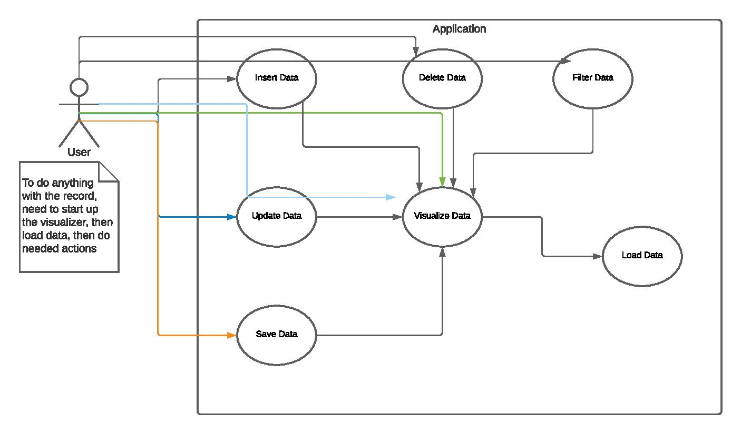

Sequence Diagram

Class Diagram

Domain Model

